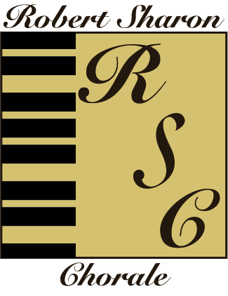

The Robert Sharon Chorale, Inc.
2255 Allen Creek Road
West Palm Beach, Florida 33411
561-687-4245
www.therobertsharonchorale.com
501c3

Hello,

I would like to take this opportunity to invite you to participate in the Robert Sharon Chorale Classical Voice and Musical Theatre Competition for Palm Beach County High School Seniors and College Freshmen. The Robert Sharon Chorale is sponsoring this competition to foster the growth of young singers and to encourage and support the development of those students who wish to pursue a career in music. The deadline for registering for the competition is Friday, January 12, 2024. The competition is open to the public and will take place at 11:00 AM on Saturday, February 3, 2024 in the Helen K. Persson Recital Hall of Palm Beach Atlantic University, located at 326 Acacia Road, West Palm Beach. You will be contacted no later than Friday, January 19, 2024 with the specific time of your performance. Singers may compete in both categories. The winners in each category will be announced at the conclusion of the entire event. First Place Winners will receive $2,000.00, Second Place Winners will receive $1,000.00 and Third Place Winners will receive $500.00. The prize money must be used for Music Tuition, Voice Lessons or Music Scores only. In addition, the First, Second and Third Place Winners will be required to perform on the Sunday, March 3, 2024 Spring Concert of The Robert Sharon Chorale, where the scholarship prizes will be awarded.

Rules and Regulations:
1. All music must be memorized
2. There is a time limit of 10 minutes per audition. If you go over the time, you will be stopped. If you are
stopped, it is not a reflection on your performance – it is so we can maintain our schedule
3. Classical Voice performers are required to have 2 selections available – at least one piece must be in a
Foreign language. We would like you to sing both songs. In case of a tie, you will select one of the two songs to perform for the adjudicators.
4. Classical Voice selections should be from appropriate Concert Stage literature – consult sources such as the
Florida Vocal Association Solo Voice list for suggestions
5. Musical Theatre performers are required to have 2 selections available from appropriate Broadway-style
literature. We would like you to sing both songs. In case of a tie, you will select one of the two songs to perform for the adjudicators.
6. No props are to be used with Musical Theatre presentations.
7. Performance time in each category should not exceed 5 minutes per selection or 10 minutes in total time.
8. One Original Score and two additional copies of each piece must be provided for the adjudicators.
9. An Accompanist will be available on-site (at no cost) if you cannot provide your own accompanist. If you
use the on-site accompanist, please bring a additional copy of the music (this can be photo-copied). If you use the on-site accompanist, you will not have an opportunity to rehearse on the day of the competition, but you will be able to meet briefly to discuss tempi and other musical nuances. However, separate arrangements can be made to rehearse (at no cost) prior to the competition – please contact Dr. Sharon directly at the number above or via e-mail: rbsharon@bellsouth.net
10. Pre-recorded accompaniment CDs are not permitted.
11.A Recommendation Letter from your Voice Teacher or Music Director must accompany the application.

All singers will be adjudicated in 5 basic areas: Tonal Quality and Production, Preparation, Musical Effect, Literature Selection and Overall Presentation. The adjudicators are professional Classical and Musical Theatre singers with established reputations as Performers and/or Teachers.

Please mail your application (click here) to The Robert Sharon Chorale at the address listed above. Please make certain your application is postmarked no later than Friday, January 12, 2024. Any application mailed after this postmarked date will not be considered for the competition. You may also e-mail the application to rbsharon@bellsouth.net. Please remember to sign your application. If you are a High School Senior, a Parent or Guardian must sign the application as well, indicating you have their permission to take part in the competition and will abide by the rules and regulations set forth.

The Robert Sharon Chorale looks forward to receiving your application and hearing you perform. We wish you great luck at the competition.

Robert Sharon Kim Genovese
Director President, Board of Directors

Artistic Director
Dr. Robert Sharon

Board of Directors

President
Kim Genovese

Vice-President
Paula Sackett

Secretary
Connie Shearer

Treasurer
Sheila Novins

Company Manager
Julie R. Bourgeois

Members-at-Large
Rusty Butler

Jane Gray Ford

Rick Genovese

Maxine Solomon

Kevin Wang

